|  |
| --- |
| Experiment No. 8 |
| Creating GUI with python containing widgets such as labels, textbox, radio, checkboxes and custom dialog boxes |
| Date of Performance: 20/03/2024 |
| Date of Submission: 27/03/2024 |

**Experiment No. 8**

**Title:** Creating GUI with python containing widgets such as labels, textbox, radio, checkboxes and custom dialog boxes

**Aim:** To study and create GUI with python containing widgets such as labels, textbox, radio, checkboxes and custom dialog boxes

**Objective:** To introduce GUI, TKinter in python

**Theory:**

Python offers multiple options for developing GUI (Graphical User Interface). Out of all the GUI methods, tkinter is the most commonly used method. It is a standard Python interface to the Tk GUI toolkit shipped with Python. Python with tkinter is the fastest and easiest way to create the GUI applications. Creating a GUI using tkinter is an easy task.

To create a tkinter app:

Importing the module – tkinter

Create the main window (container)

Add any number of widgets to the main window

Apply the event Trigger on the widgets.

Importing tkinter is same as importing any other module in the Python code. Note that the name of the module in Python 2.x is ‘Tkinter’ and in Python 3.x it is ‘tkinter’.

**Program:**

import tkinter as tk

from tkinter import messagebox

def stop_application():

    root.destroy()

def submit_form():

    name = entry_name.get()

    email = entry_email.get()

    age = entry_age.get()

    # Check if any language is selected

    if language_var.get() == "":

        messagebox.showerror("Error", "Please select your favorite programming language.")

        return

    # Get the selected language

    language = language_var.get()

    # Get the selected gender

    gender = gender_var.get()

    # Get the checked hobbies

    hobbies = [hobby for hobby, var in hobbies_vars.items() if var.get()]

    # Display submitted information

    message = f"Name: {name}\nEmail: {email}\nAge: {age}\nLanguage: {language}\nGender: {gender}\nHobbies: {', '.join(hobbies)}"

    messagebox.showinfo("Form Submitted", message)

root = tk.Tk()

root.title("Comprehensive GUI Application")

# Labels

label_name = tk.Label(root, text="Name:")

label_name.grid(row=0, column=0, padx=10, pady=5, sticky="e")

label_email = tk.Label(root, text="Email:")

label_email.grid(row=1, column=0, padx=10, pady=5, sticky="e")

label_age = tk.Label(root, text="Age:")

label_age.grid(row=2, column=0, padx=10, pady=5, sticky="e")

label_language = tk.Label(root, text="Favorite Programming Language:")

label_language.grid(row=3, column=0, padx=10, pady=5, sticky="e")

label_gender = tk.Label(root, text="Gender:")

label_gender.grid(row=4, column=0, padx=10, pady=5, sticky="e")

label_hobbies = tk.Label(root, text="Hobbies:")

label_hobbies.grid(row=5, column=0, padx=10, pady=5, sticky="e")

# Entry Widgets

entry_name = tk.Entry(root)

entry_name.grid(row=0, column=1, padx=10, pady=5)

entry_email = tk.Entry(root)

entry_email.grid(row=1, column=1, padx=10, pady=5)

entry_age = tk.Entry(root)

entry_age.grid(row=2, column=1, padx=10, pady=5)

# Dropdown Menu

languages = ["Python", "Java", "C++", "JavaScript", "Ruby", "Other"]

language_var = tk.StringVar()

language_var.set("")  # Default value

dropdown_language = tk.OptionMenu(root, language_var, *languages)

dropdown_language.grid(row=3, column=1, padx=10, pady=5, sticky="ew")

# Radio Buttons

gender_var = tk.StringVar()

gender_var.set("Male")  # Default value

radio_male = tk.Radiobutton(root, text="Male", variable=gender_var, value="Male")

radio_male.grid(row=4, column=1, padx=10, pady=5, sticky="w")

radio_female = tk.Radiobutton(root, text="Female", variable=gender_var, value="Female")

radio_female.grid(row=4, column=1, padx=10, pady=5, sticky="e")

# Checkboxes

hobbies_list = ["Reading", "Gaming", "Traveling", "Music", "Sports"]

hobbies_vars = {}

for i, hobby in enumerate(hobbies_list):

    var = tk.BooleanVar()

    checkbox = tk.Checkbutton(root, text=hobby, variable=var)

    checkbox.grid(row=6+i, column=1, padx=10, pady=2, sticky="w")

    hobbies_vars[hobby] = var

# Buttons

submit_button = tk.Button(root, text="Submit", command=submit_form)

submit_button.grid(row=7+len(hobbies_list), column=0, columnspan=2, padx=10, pady=10)

stop_button = tk.Button(root, text="Stop", command=stop_application)

stop_button.grid(row=8+len(hobbies_list), column=0, columnspan=2, padx=10, pady=10)

root.mainloop()

**Output:**

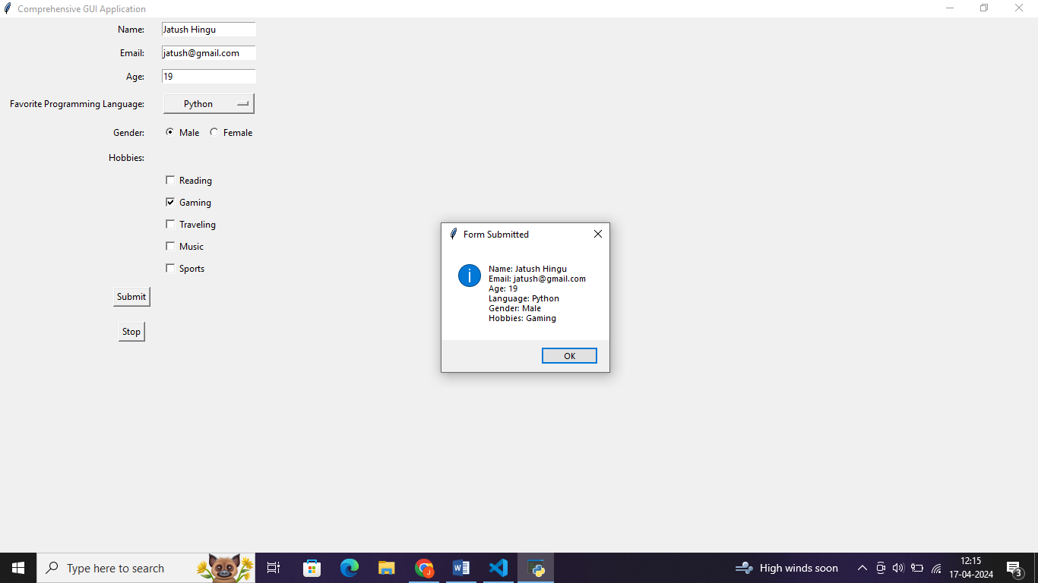

**Conclusion:**

Through Experiment No. 8, the process of creating GUI applications using Python's tkinter library was explored comprehensively. Various widgets such as labels, textboxes, radio buttons, checkboxes, and custom dialog boxes were utilized to develop an interactive form. This experiment served as an effective introduction to GUI development in Python, showcasing its versatility and ease of use. Overall, the hands-on experience provided valuable insights into the capabilities of tkinter and its practical applications in building graphical interfaces for Python programs.